PILCOMAYO trip 3.10.2012 & more

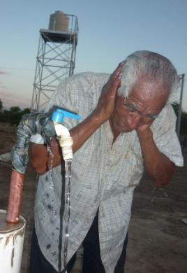Of all the little successes we can have, I consider that moving strings so that the people have good access to water is on the fist line.

We see here Jose Pedro, elder of San Luis community cooling down with water from the pump just connected to the electric grid. With days of 46º cent water is essential to health and family agriculture in this case. The tap could do with a service but that´s another story.

There is one main shout from the Pilcomayo to the Bermejo: GIVE US A BETTER SERVICE OF WATER

On the 3rd of October I left Salta for Misión Chaqueña. There were glasses to be given as we had taken Dr Mirko Guberman, optician from Jujuy, to attend to the wichi of both Salim and M. Chaqueña. Over 60 glasses were prescribed and 3 cataract operations. Sadly Arturo Rey and Emiliano Diaz were two of the ops to be done but they died before being operated.. There is a criollo still to be done.

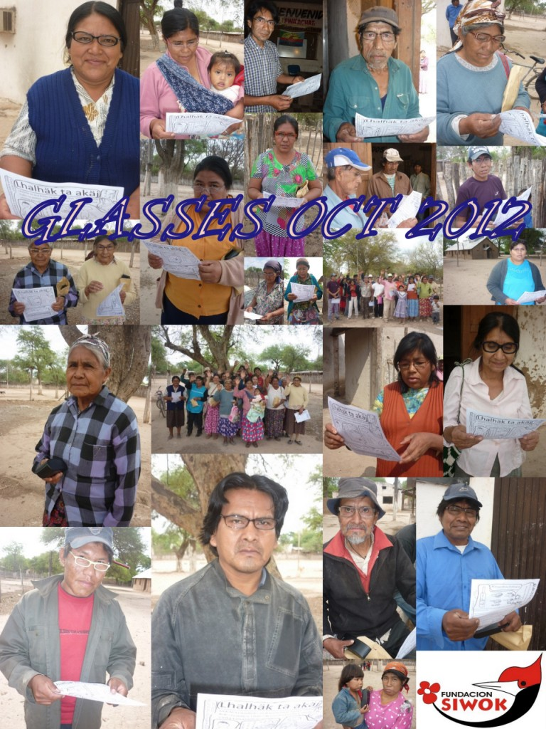

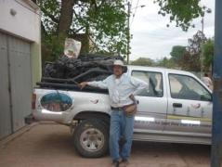Above some of the wichi that recieved the glasses. They are reading the leaflet we designed for better eating, nutrition and some agriculture suggestions. All were very thankfull for the glasses as most are craftmen and eyes are a need tool.

I left for the Pilcomayo that mid day with 20 irrigation kits that Antonio Gomez had prepared.
They have 14 furrows, 20 mts long and fit in a 10 meter wide “olafwek” (closed in garden). With that they can produce 1600 maize cobs in around 90 days (depending if they have water!). Here about to leave.

I went by Tartagal and from then on 3 hours more on the dirt road to tha Pilcomayo. Not as many bushes in flower but still some interesting ones like these climbers family of Bignonias that also include the jacarandas and lapachos, typical trees of NW Argentina.
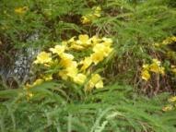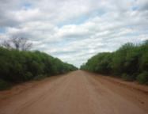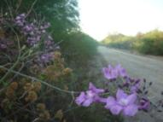

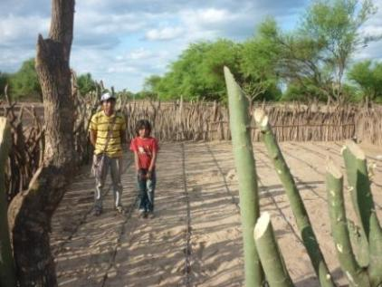I got to La Puntana, Wichi community on western end of all the river communities that borders Bolivia.
Valentín Diaz one of the local leaders had just finished his new enclosure and the irrigaton kit was working. I suppose he knew I was coming.
Sandy soil needs manure as you can see. Part of my speech.

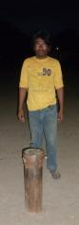I visited all the families that we had given irrigation kits but only one had maize plants to show. One of the reasons was lack of water. Here on the left one of the 3 incomplete wells that are monuments to wrong priorities by the government.
One of these wells wasn´t even on the list of wells that they had as jobs to be done. Two institutions had worked on parallel roads and nobody new it existed.
When I mentioned this to one of the wichi from the missing pump community immediately he said they would let them start the other 2 pumps that were on the list and when all was working then they would take over the premises and not give them back till the other pump was put on the list. At that moment I thought it was the only road. The end of the story was that when back I had an urgent meeting with the minister of health where I mentioned this and now he has put this other pump on the to do list.
I till night time I was visiting families that had an enclosure and another 7 received kits.
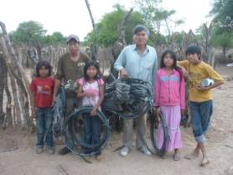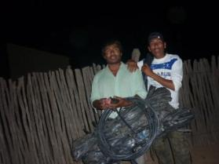
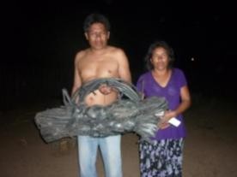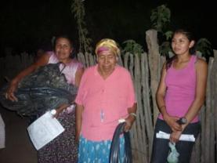
Here above some of the people that received the drip irrigation kits. Edward Diaz (¡!), Ruben Diaz, Adrian Diaz, Evangelina, Kutsaj Suarez, Guillermina, etc. As you see it was late at night by this time so I asked for a bed and one of the families offered his daughters house as they were away in Tartagal.
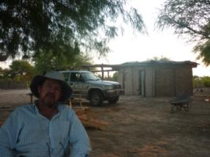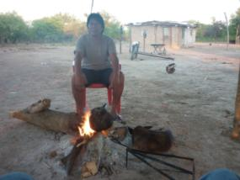
I slept very well surrounded by fishing nets and adobe bricks. Here my host Ricardo preparing mate.
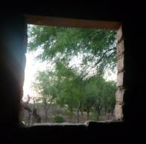
There is new film just been shown on a national level called Nosiliotiaj “The Beauty” done by a local director that tells the story of a wichi that working as a maid in a criollo family gets her long hair cut so that the daughter of the house would be better turned out for her 15th birthday. If it´s on Youtube I suggest you see it. It was filmed here in La Puntana and the main actress also comes from here. This photo at left I took because it was the same as one shot I saw in the film. As a sign of respect the director showed the film here before the rest of the country.
I left early for La Curvita where Rogelio Segundo and family had sown watermelons with little success as the birds and a little red spider caused havoc. Plants that were saved from the birds were hit by the spider. These below were the culprits: Naranjero and Pepitero.
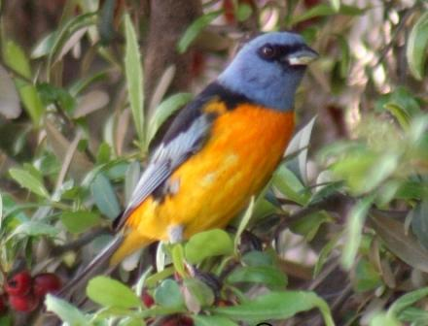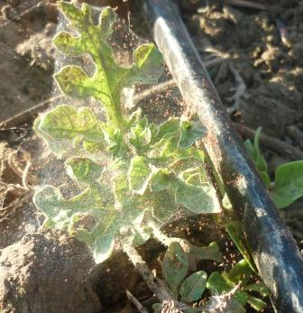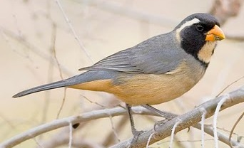
Rogelio had done very well last year, harvesting more than 500 watermelons. We will have to invent something against the birds. Cats tied to a tree, caged owls, and sun dried falcons in flight were proposed.
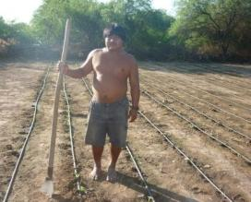Who had a good sown plot was Pedro, here with his worn out spade. I should a hoe in my kit. Pedro is Chorote (another tribe) and very enthusiastic about sowing. As he was so interested we left an extra irrigation kit for his dad.
Interesting to mention that there is a curve of enthusiasm. It goes up the first year then down the second. Keeping the interest high I suppose is partly my job.
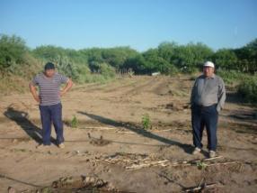
Here Rogelio and his father Cornelio with his failed watermelon plantation. He is going to sow maize now, if the birds let him!
I left insecticide (horrible smell so nobody touches it) for the little spiders but it was too late.
I left another kit there for a neighboring community Monte Carmelo. Rogelio would explain to put the kit together and sow the maize right.

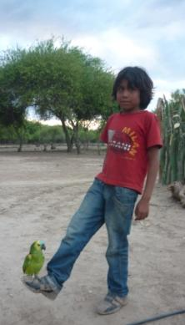Having wichi teach the wichi is an objective I have in mind. It´s obvious that working now on the two rivers I can do a limited amount of work so the only way is to train wichi to do the extension work.
I have put together a project called: “Wichi Agriculturists” which I have presented to the health and production ministry. The main idea is to have a leader per zone with a motorbike and stock of materials. All involved have phones and can speak free between each others and me on the other end.
As with the crafts many years ago we have to be creative and “invent” a new way to produce food for many.
From La Curvita I went to Santa María where my right hand man Francisco Perez was waiting.
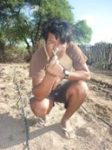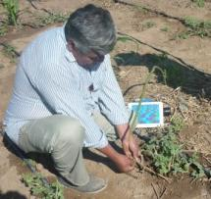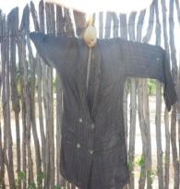
Here the attack by the birds was also evident. Nobody had watermelon plants. Only maize was growing. It´s a lesson for the future: if we don´t invent some sort of protection agaist the birds we can´t lose time with watermelons. Maybe you wonder why so so much interest in watermelons… well with 45ºcent a hot December a watermelon is a gift from God! (…and can also be sold as gold!). Francisco at middle with a wichi “flexible stick trap”. The bird steps on sticks that set off the trap. A noose which in theory should get the culprit.
The wichi say that birds will stop the attack when the fruit of the “ancoche” palnt ripens. This means that there will be food in the forest and they don´t need to poach on the gardens. 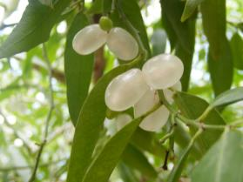
Here at left the fruit we´re waiting for.

Here below some gardens in Santa María. We had worked with over 40 families last year so there were people that had started earlier and others waiting to start. Beolow gardens of Victor, Lázaro, Ramón y Nicolás.
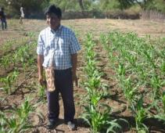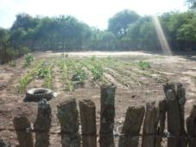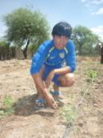
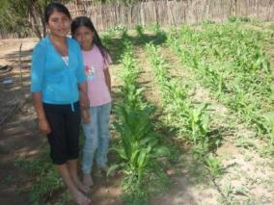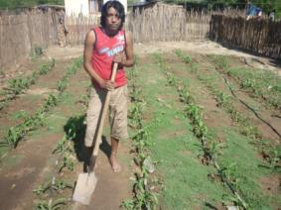
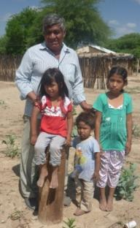If there is water this we should have arround 80 gardens this year.
All depends on water. Here Francisco and kids on Santa Maria´s unfinished well, another monument to inefficiency.

It´s scandalous that infant mortality is 8 times higher here than the national average. (One child in a 100 will not get to 5 years old in Salta province but 8 in 100 willnot get to their fifth birthday in the indian comunities. These are official statistics and they don´t take into acount kids that die but were put in the civil registry.
Of the 7 unfinished pumps 2 were not connected to the electricity for 2 years and now we have succeded to connect them. The other 5 pumps are still to be finished and I´m pushing for that to happen. In theory my meeting with the minister after coming from the Pilcomayo put a bit of pepper in the sauce and he sat all the service companies arround the same table asking for action.
My reading is that the Indians have never been a priority and when one says this in direct way with the authorities high up , you get results because it´s so obvious.
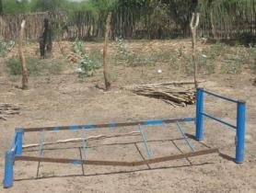 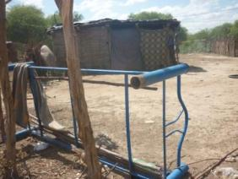I
Indirectly related to what we said above about priorities you see all these 5th rate beds lying arround the community. They come from Buenos Aires in truckloads. Horrible quality chairs and beds to be given away before elections. Once again the priority is get the votes not the better education, health or development of the Indians.
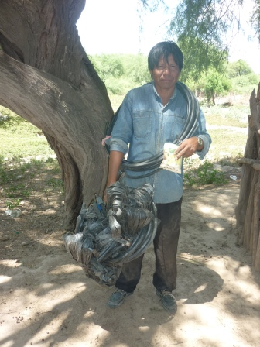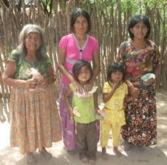
We had seed and irrigation kits so we gave 10 to interested families. We have taken to the Pilcomayo arround 80 kits since we started the project in August.
Further ahead we met a family that had worked very well last year and that in a wichi conflict solution classic had moved somewhere else. (That´s how conflicts are sesolved… you pick up your few belongings and move). Six families were sharing a 1/2 “ hose for their water so we measured the distance to the main hose line and made a note to send the hose to bring more water to them. This has already been done.
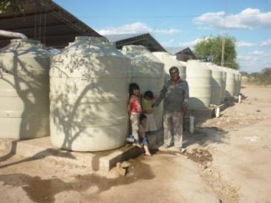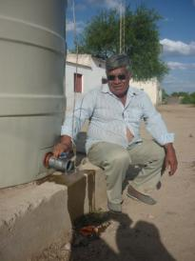
We got to Francisco´s community Cañaveral where he ahs a wáter catchment Project that had no wáter. It shows that when it´s most needed (oct-nov) these systems don´t work. Nothing better than a pump that works all year round.
Here also there is an unfinished pump.
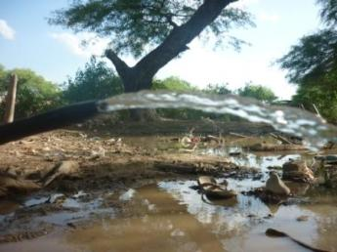One has to mention also that it´s not only lack of pumps but also broken water pipes like these at left in Francisco´s community.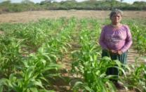
Juana above with her maize plot but very annoyed at lack of water.

.

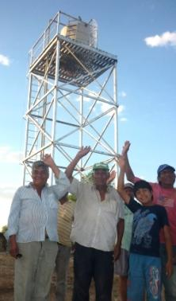We went on to San Luis community where tha day before (they knew we were coming) they had connected the pump to the electric lines. For 2 years this was incomplete in the extreme temperaturas of the Chaco. It would of carried on this way had we not visited the boss of the electric company in Salta. They had in their computer written down that the pump was working well connected to the school.

Here we see the tank overflowing with water. GOOD NEWS!!

We still have to succeed in connecting this tank to the wáter grid of the community and for that we need 75mts of thick hose. Slowly but steady we´ll have it done.

The other pump at Arenal that had also been unfinished has today been connected (today 22nd Oct). Also very good news.
Som gardens at San Luis done by Felipe, José Pedro, Miguel y Guillermina.

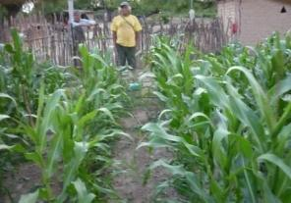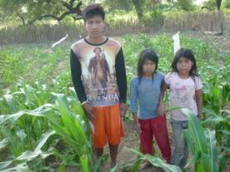
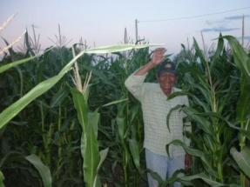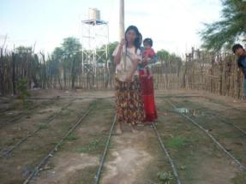
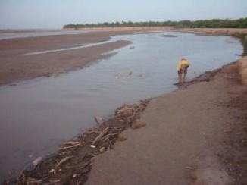It was VERY hot and I was feeling dizzy so I decided to go with Felipe to the river and have a dip.

The river is cutting into the land and all were wondering if it would swamp San Luis this coming rainy season.

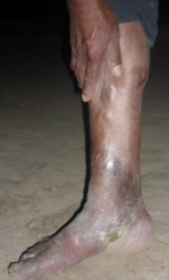Before getting into the wáter I asked Felipe about pirañas and he showed me his leg with lots of bites. The colour was not very healthy either…

We later ate fish with our fingers. You go spitting the fish bones to the floor and the dogs rush in to munch the thin as needles bones. The lady of the house generally is behind you with a stick shooing the dogs away.

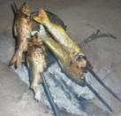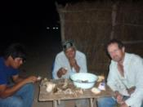

I got back to Santa María late to sleep in Helena and Cris Wallis´s house. They were not there. All beds were covered with a 5mm layer of dust. Knowing the hot dusty north wind Helenita had covered all with plastic sheet.
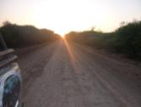
Early I set off for the Bermejo communities of Hickmann. I had organized to connect with Antonio there to see the work he was doing there and in Dragones, the community further down the tracks. You can get to the Mision now from Hickmann. Before we had to cut into the forest through private land that was a bit adventurous…

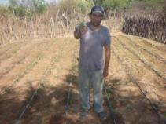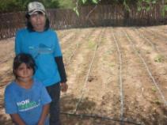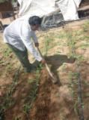
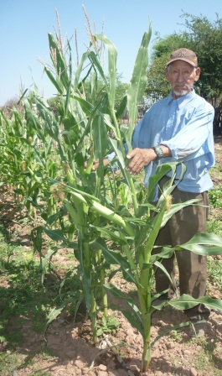
Here some plots of this area: Lino, Molina and Bailon.

Molina has 2 kits, one for watermelon and the other for maize. Once again the birds had attacked the melon plants when little and there was nothing to show.

Simon Argamaza here at left.
Not many maize plants but they have cobs about to mature now.

These people live mostly from donations and have the worst malnutrition and infant mortality statistics.

We pretend to organize the Wichi Agriculturist Project” for places like this. Far from our beaten track but easy to get to if you go in a motorbike.

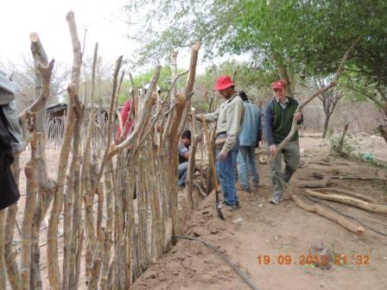

A week after going to the Pilcomayo I visited Hickmann with Phil and Rosemary Tadman. It was a pleasure to share the time together and they could see hands on what we are up to.

Her is Phil hands on to finishing Lino´s fence!

Now in Misión Chaqueña I visited some intensive agriculture plots.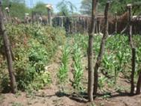 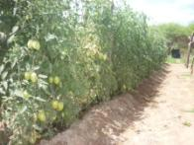 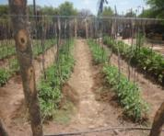Tomato and Maize in Antonio´s and more tomato in Balducho Villafuerte´s place. Doing tomatoes at this time of extreme heat is not my suggestion but it´s working as you can see.
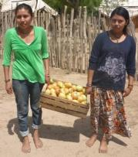The Vazquez family from Salim greeted me with a big box of tomaoes of they´re own produce. They taste better when we know the effort that it takes to produce them.
Alejandro, one of Vasquez´s sons, was sent last year by F. Siwok to the south of the province of Buenos Aires to learn how to manage bees. He´s a smart young man and we hope to support him in the future.

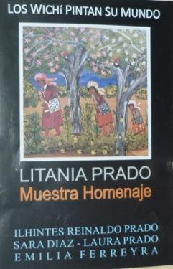
Other themes: 1- The 10th of October we helped organize an exhibition of Wichi paintings in the local Fine Arts Museum. We brought Sara Diaz and her daughter Emilia who painted the two first days of the exhibition. It´s open till the end of the month. Promoting painting documents a fading cultura, gives needed work and protects the forest. See more: http://www.eltribuno.info/salta/212941-Muestra-de-dos-artistas-wichi.note.aspx

- It seems that my meeting with the health minister had a good side effect as 3 pumps are being finished now in La Puntana and the next one in line is Santa María. Let´s hope they finish before the rains. This will mean that more people can participate in the garden Project.
It´s very good news!!

- Two days ago Fundación Siwok was given by the local Agriculture Ministry a 25.000U$D cheque to invest in water systems. We are teaming up with some people from Cordoba who want to drill a pump donating their labor and machine costs. This money will help to buy the pipes and water tank plus pay for the costs of bringing the drilling equipment. Better water will mean more health and development. GOOD NEWS ALSO!
- I´ve got to mention that the foundation does not own a vehicle (does not own anything really!) and I use my own personal truck to do the work. As it´s getting to it´s 10th birthday it would be wise to turn it into a newer model. I think it´s important to let you know this situation exists. Maybe there is somebody out there willing to help with this.

CONCLUSIONS:

- Water is still the number one area where we must insist a better service. All incomplete pumps must be finished.
- A paralel Project must be put together to stop the loss of wáter due to broken pipes and taps.
- We will be trying solar pumps for places where no electricity exists.
- The wichi themselves will have to take up the expanding of this garden Project. We need the government to promote wichi agriculture extension workers.
- Plant loss due to bird attack is preventing us expanding agricultura. We need to learn appropriate systems to control the pests.
- Weed contol which we thought understood has to be bettered. We should include hoes in the kit.
- We are getting to new communities and this is positive for the future as more families in these forgotten places can see another survival strategy and add it to the existing ones.
- The exodus of young people in search for work carries on. We must put all our effort to develop income generating tools such as crafts, painting, honey production, etc. Other new options could include also aquaculture, ostrich farms, etc.
- We will carry on taking medical doctors to help with eye problems. The prescritptions for glasses were highly valued by all.

Thank you very much for your support. Blessings to you all and let´s keep connected.

Alejandro D. Deane
Gral Güemes 164 Dpto “B”
Salta 4400- ARGENTINA
alecdeane@yahoo.com
Cel phone: 0054-387-155096482
House Phone: 0054-387-4229249

These are the two links if you want to see our last two reports in Spanish. http://www.sendspace.com/file/xin0hv
http://www.sendspace.com/file/oz0tns

BONUS:

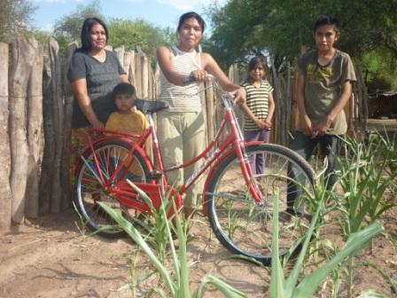

THIS IS ALBINA CHILANGO FROM CARBONCITO WHO GOT THE PRIZE FOR THE BEST MAIZE PLOT IN THE SCHOOL.

THIS WAS GIVEN LAST WEEK ON A VERY HOT DAY. SEE THE MAIZE SUFFERING.

