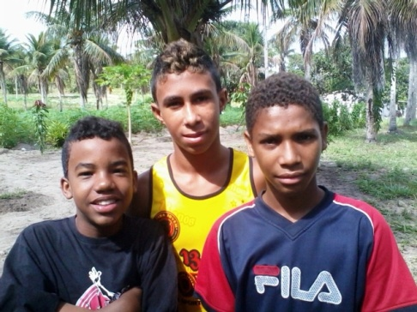CASA DE MEU PAI

My Father`s House

Av. Ministro Marcos Freire – 5657

Rio Doce – Olinda / PE CEP: 53.030-000
CNPJ: 07.027.470/0001-98

Fone: 3429.0278
COMDACO 68/06 - CMASO 140/2006
www.olindamission.no-ip.co.uk

Prayer Points – February 2013

The world seems to be turning upside down! England beat Brazil at Wembly! The Pope resigns! While we are here in the middle of Carnival and there is no rain! Meanwhile here´s a few of the things that have been happening in Olinda and My Father´s House:-

As is normal at the beginning of a new school year we have fewer boys at MFH at the moment. Emerson, Deybson, Gabriel, Victor, Daniel, Jamerson and Rafael who we expect to be able to return home fairly shortly.

At Living Water´s Church we decided not to go out to the farm for the 5 day Carnival holiday, but instead hold our 7th Mission School based at the church, in preparation to introducing small home groups into the church and reducing the number of ministries as an important part of our growth strategy for this year. This will need much prayer as we prepare leaders for this task.

Not using the farm has also enabled us to rent is out for the holiday to our Presbyterian friends who have filled every inch of it with over 200 teens! Three of our boys were not able to stay with friends or relatives during the holiday, so they also came to the farm. This enabled me to spend more individual time with them and talk a little about their dreams for the future, in fact to stimulate them to begin to dream, as they have very little idea of what is possible for them to achieve. Here´s a little of what they said:-

“ Hi! My name is Gabriel, I am twelve years old. This year I will study in the fifth year at school. Please pray for my studies so that I can learn a lot a get a place in university. The subjects I like most are math’s and science. I also like to study the Bible and believe that Jesus has a special plan for my life.”

“Hello, may name is Emerson. I am fourteen, and this year I will study in the sixth year at school. I like Portuguese and English most, and hope to study languages at university. During the Carnival holiday I asked to go to the farm because my mother is mentally sick and lives on the streets, and I don’t like to go to my aunt’s house”

“Hi! My name is Daybson and I am twelve. I am spending the Carnival holiday at the farm with Pastor Ian. My mother killed herself when I was seven and my father is a drug addict, who spends most of his time on the streets. I have two brothers and one sister who live with my grandmother, but she doesn’t like me. At school this year I will be studying in the fifth grade. I most like science and one day hope to become a scientist and invent new things. Please pray for my future.”

In fact these three are the most advance in schooling, probably because they have been longest in care! Most of the others are way behind, and still have difficulties with simple reading and writing, for which there is little school help because of their ages.

Now Carnival is ending and the years work is beginning in earnest. We have to renew much of our documentation within the next eight days in order to qualify for government recognition and support for 2013. So it´s now back to Olinda and leaving behind the peace and quiet of the farm. However, as we move into lent at church, please pray that we may learn more of that “Peace which passes all understanding”

God Bless, Ian and Siméa.

