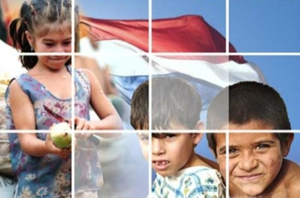
Ana has just sent us this update from Paraguay.
Friends of FEISA,
We returned on February 1st, keen to serve God by training young women to work with children in Early Years Education, in our beloved Paraguay.
At the beginning of this year, God spoke to us through Colossians 3: 15 “May the peace of God reign in your hearts, because it is for this that you were called together in one body. Always be thankful.”
In these words we find 3 challenges for the whole team in FEISA.

- Peace: beyond all material or human circumstances; God is in control; He meets all our needs.
- Unity: we are part of a single body,called to fulfill a part of Christ’s work in the extension of His Kingdom here on earth.
- Thankfulness: how easily we focus on our needs and petitions and forget to give thanks, when we have so much to be grateful for!!
Important Dates
On February 14, we’re offering a workshop to orientate FEISA teachers who plan to help our degree students prepare and defend their theses. In 2011, only 3 out of our 15 degree students actually defended their theses.
Around February 15, depending on the school, our 3rd Year students will begin practices in Christian pre-schools, spending a week with teachers preparing their classes, and the following week, helping 5 year old children adapt back to a school routine.
On February 20th, our Second Year students will start 2 weeks of workshops in creative arts and physical activities.
On March 5th, all 1st Year students will begin a “vocational practice” in Christian schools. They will observe infant teachers on the job, helping with whatever they are asked to do. The idea is to give the students an opportunity to decide if they really do want to work with young children.
: Praise God for

- Each person who supports us in prayer and with their financial gifts.
- All those who work in FEISA, teachers and administrative staff, and for all the different gifts He has given each one to fulfill his or her role.
- His provision for 2011 and for enabling us to start this new year.
Ask God for

- 30 + new 1st Year Diploma students and 20 + 4th Year Degree students.
- The thesis workshop – that the right teachers would attend and be helped by it, so that the remaining 12 students may be able to defend their theses this year and so obtain their degrees.
- The 1st and 2nd Year students starting their teaching practices – that they may have sufficient resources to cover their transport costs and the materials they will need to use.
- The donations needed to cover our 2012 budget.
- The possibility of starting an exciting new project offering a Specialisation Course in Early Years Education, to trained teachers, who are working as infant teachers but who have not received specific training in that area.

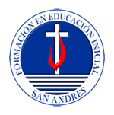
UK contact: Colin Voutt, colin@voutt.myzen.co.uk
Greendown Terrace, 164 Bradford Rd. Bath BA2 5BZ

We are seeking to from professional teachers of integrity who will contribute to a more just and worthy society, helping children to be more secure, more competent and happier, and thus able to build a better PARAGUAY.

