
“YACHUYAJ WO” GARDEN REPORT
December 2013

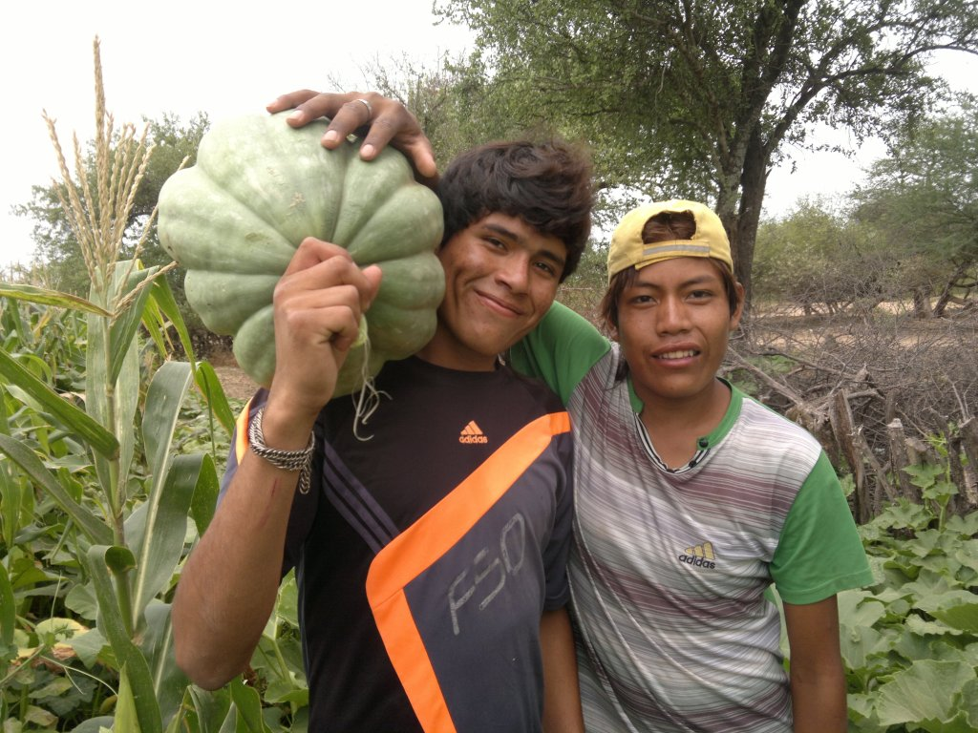
Harvest at La Puntana Chica

I was invited to share my experience on development with the Wichí at a meeting run by a very knowledgeable anthropologists and many Roman Catholic social workers. The center of discussion was this quote from a Franciscan ethnographic scholar back in the beginning of last century. It went like this:

" Among all the South American Indian tribes , [ ... ] this tribe generally speaking, is the most degraded and the most refractory to civilization [ ... ] . The inteligence of the Matacos is generally
extremely limited and their understanding is so diffuse that they miss to understand the simplest of things . [ ... ] This lack of understanding even exits in areas that would result in their own convenience and would affect their welfare for the better. [ ... ] I proposed that
they would sow a lot of maize , which would provide enough food to eat during the next year and even they could sell any amount they would chose… I offered oxen , plows, seed and free food. As my proposal was advantageous they accepted it on the spot. They began the work, but the next day they said they would not continue because the wage I offered was not good. In vain I tried to persuade them , making notice that the oxen , plows, seed and food would be for them. This reveals the largest stupidity that could fit a human head. "
( Franciscan Rafael Gobelli , " Ethnographic Study of Matacos Indians " [1913 ]

These words sound very harsh but are common thinking with the general Salta public. They condensed what many think but don’t say and the people organizing the get together wanted to know why my 30 years experience working in economic development was different. We have been able to set up sustainable ways of generating income for the Wichí that still today work through crafts and now agriculture. Although producing crafts is not the same as sowing maize there are many parallels.

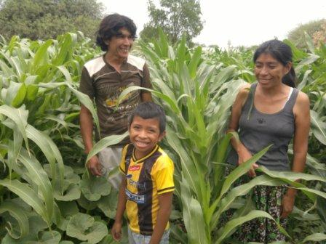
The first reason why, in my non scientific view, projects fail is because we don’t adapt to the people and expect them to adapt to us. Communication in their language, think small, work with the family unit, depend and value their initiative, etc. The second big reason is what I call the “worker on a salary” syndrome. This goes especially for government workers but also can be said for some NGOs. There has to be commitment to get the work done. I quoted in front of all John 10 vs 12-¹² The hired hand is not the shepherd and does not own the sheep. So when he sees the wolf coming, he abandons the sheep and runs away. Then the wolf attacks the flock and scatters it. ¹³ The man runs away because he is a hired hand and cares nothing for the sheep.13 “ The third reason is that they recognize me as a member of the Church.
Obviously, putting the responsibility on the “external team” was a bit of a shock but it’s as I see it. It’s my fault if things go wrong, don’t blame anybody else. Fr. Gobelli should of got closer to the people and understood how they think and who and how he should work with so it was HIS fault and not these well mannered people.

Throwing the ball to their field I suppose has had them thinking on my strategy of development work. Many may have discarded my proposal but what can’t be criticized is that after over 30 years of work there are concrete fruits of the Siwok strategy that are visible to the eye so there must be some wisdom in what we were proposing.
I was insisting that they travel 60 km East to see what was happening with the gardens in Hickmann but nobody could make the trip. I left 4 irrigation kits with the group which I hope will be used to produce needed food.
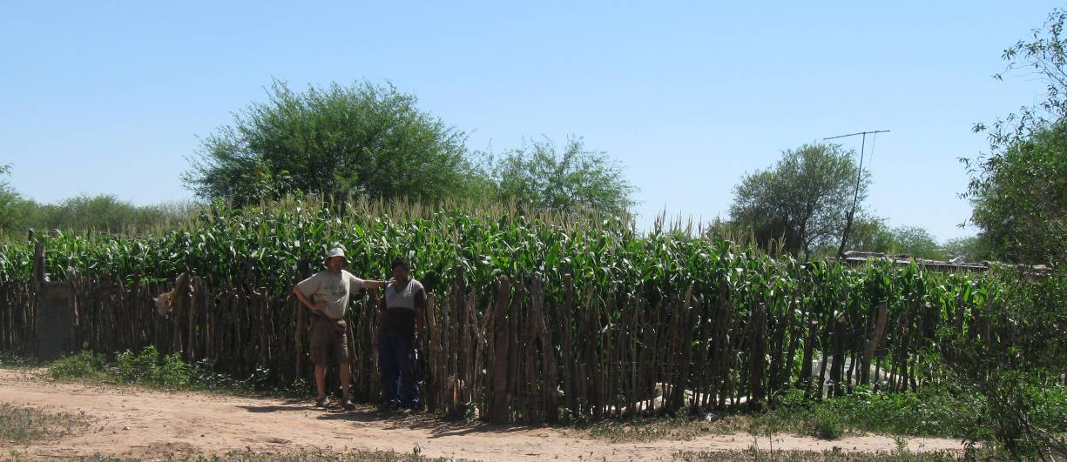

While we were deciding on the future of mankind this was happening in the Wichí community of Hickmann, a very poor place where there is rampant malnutrition and infant mortality.
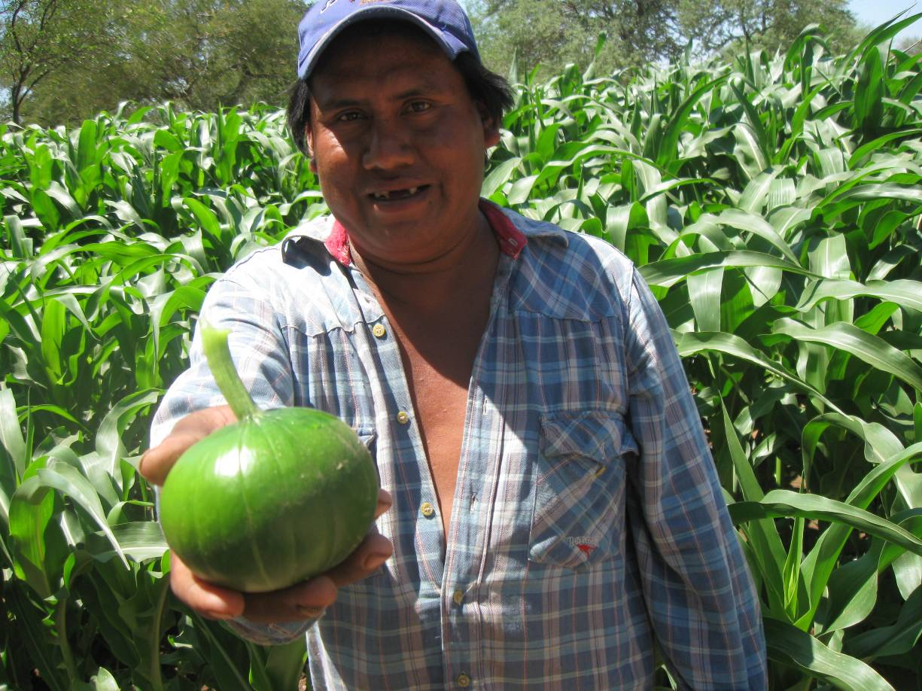
Families that had sown early were now harvesting maize and pumpkins. Lovely green crops…

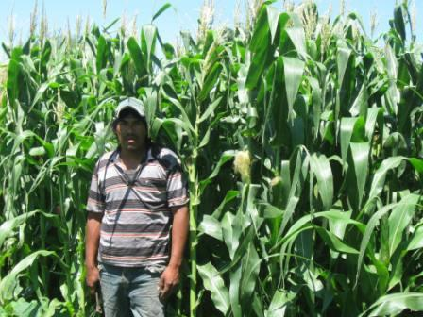
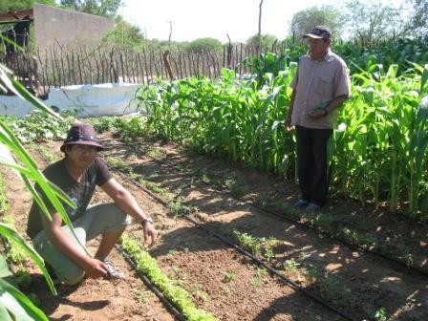
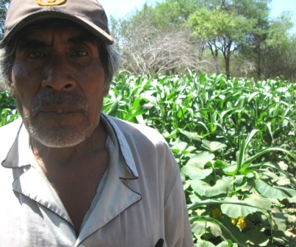
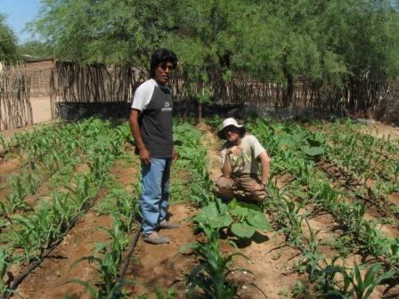

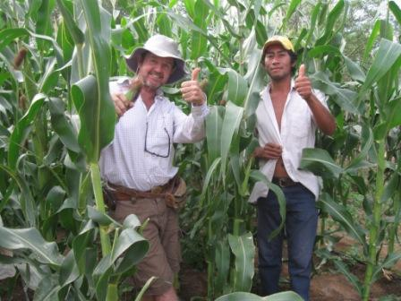
Here left, Roberto with me in his garden about to be harvested. There are now 10 gardens in Hickmann. A little success story… As is our experience elsewhere the initiative to sow starts with a family leader and then other relatives finish the fencing of their own garden (it’s the only condition we ask) and accept the offer of good seed and drip irrigation equipment.
Somebody stole my photo camera so I’ve had to film these videos with an old apparatus. Sorry, we will do better in future videos.
Here I show how the gardens are contagious to family. The man starts on one end and goes adding on to the back with father and brothers coming into the system.
https://www.facebook.com/photo.php?v=425634324228993&set=vb.100003472876345&type=2&theater

Here is Fernando´s neighbour, Donaldo, who was looking from the sideline but now has his own garden and father in law also!

https://www.facebook.com/photo.php?v=425625027563256&set=vb.100003472876345&type=2&theater

This little man, brother of Roberto, had come some weeks before to ask for 100mts of hose to connect his house to the main line. We helped him and now he is very thankful of the support. I always mention that this help does not come form politicians but from brothers very far away.
https://www.facebook.com/photo.php?v=425629237562835&set=vb.100003472876345&type=2&theater
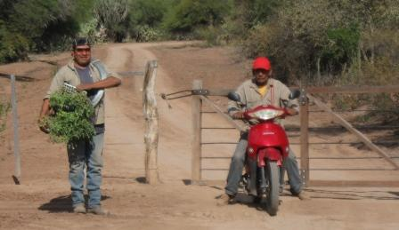
We started the work in Hickmann a year ago going in cheap Chinese motorbikes. Here Antonio, our right hand extension worker, with his nephew and tomato seedlings ready to plant. It’s a 40 minute ride to this community from Misión Chaqueña.

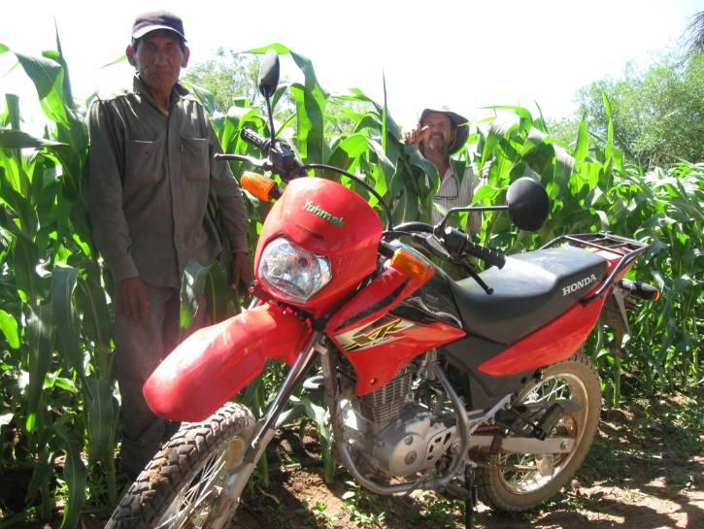
We knew we were in trouble with regards to mobility as the bikes we were using (Antonio´s) were being damaged by the bad roads. A contact we made at the Argentine British Chamber of Commerce (we got 3rd prize in a national competition for sustainable new ideas) was a Christian from a Presbyterian Church. He decided he wanted to give us a motor bike and so he did. Now Antonio does his rounds in an Honda 125cc made for rough roads. Here the beast…

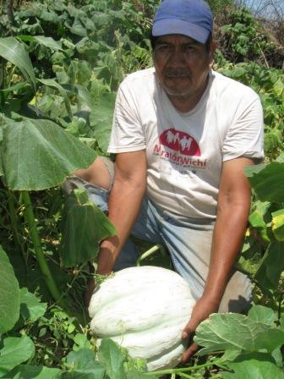
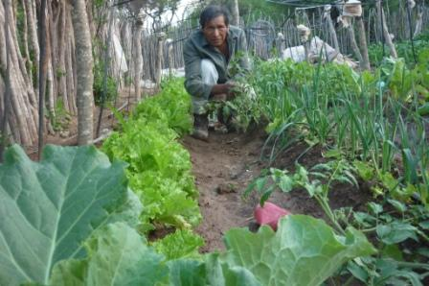
Here some gardens from the Misión Chaqueña area.
Pedro above with different species of onions, lettuce, cabbage, tomatoes, etc. Naldo with large pumpkin.

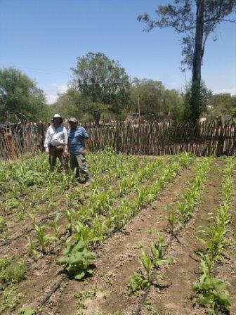
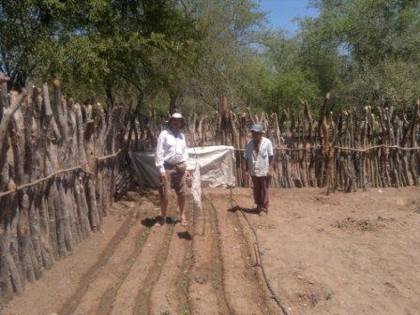

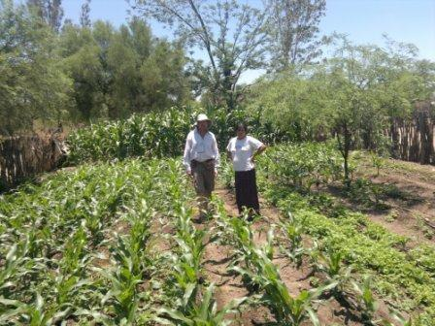
At left gardens in Misión Salim. Above a new garden in San Ignacio where we have just started to work, thanks to the motorbike! The man did not understand how to use the drip hose (you can see the head of furrow hose going parallel to the sowing which is the other way round!). Both these places where many families live now in peace, having the title deeds of their land, are a product of wise land acquisition decisions taken in the 70´s. The Wichí are very thankful for this and defend the church.

There are around 40 gardens in the Misión Chaqueña area. Hickmann 10, Salim 10, Misión Chaqueña 15 and La Esperanza 5). These should produce 2 or 3 harvests till the frosts and from February on they will be producing winter high value crops (tomato and peppers). Last year’s experience has taught us that all produce done in winter will have strong demand and that we could produce 10 times more and it would be sold. Also Wichí have accepted tomatoes as part of the diet and consume them with glee…

One area where we have been recently involved is in providing better water facilities and pushing authorities to finish pumps. I brought water to be analyzed from La Puntana, the last of the 8 unfinished pumps to produce water (but the people said it was salty, that’s why I brought some to be checked chemically).

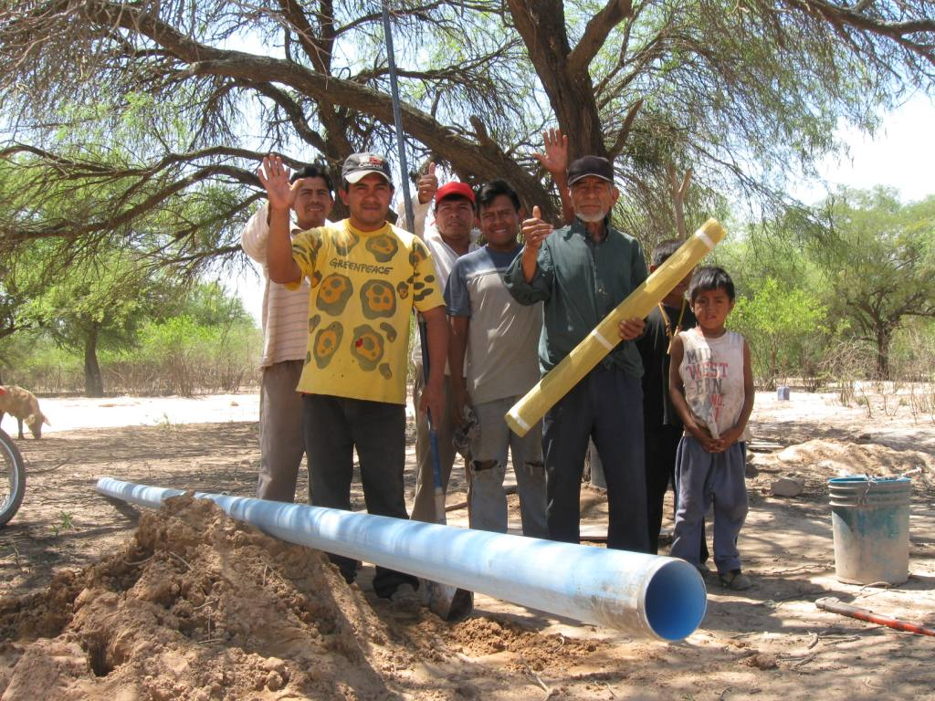
Here the Marquez family VERY thankful for the help they received. They needed a pump for their hand well, we got it thanks to my brother JMD and then the bore hole piping was twisted so they had to dig it again. Here below is the little video of them and their thanks message. Excuse the quality of the video!! As my camera was stolen I had to tape with an antique version...

https://www.facebook.com/photo.php?v=425556344236791&set=vb.100003472876345&type=2&theater
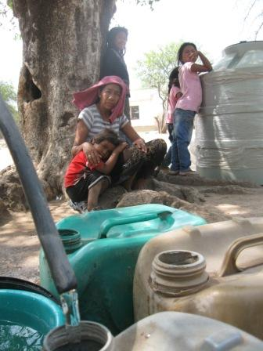
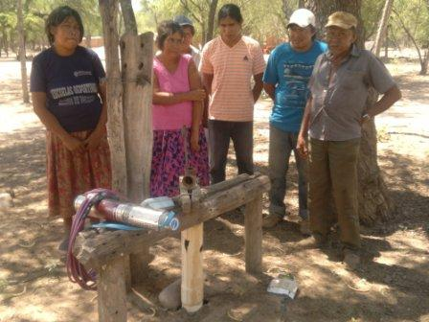
Through contacts (JMD again!) we were able to provide a water tank for this Barrio in Mision Chaqueña and a new electric ½ HP pump for San Ignacio community. The money for this came mainly from Facebook! I started uploading the videos there and now we have many friends that like what we´re doing and sometimes are interested in supporting this sort of initiative.
Now I post photos and videos on the work being done and it’s good to see the “fan club” growing! Contact us through the Fundacion Siwok Facebook account.

We are leaving Misión Chaqueña area and we are off to the Pilcomayo 250km NNE…
This is my 5th trip there this year and it’s a great pleasure to visit and do the rounds through the communities.

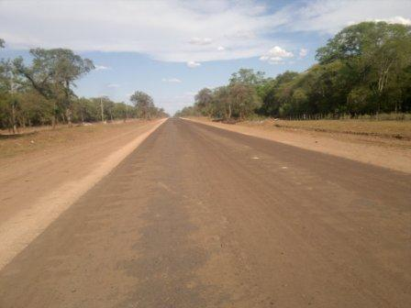
The first shock you get is seeing how the paved road is advancing into the Chaco (it will connect Tartagal to Misión La Paz).
Seeing it changing the scenery, the work done by the church comes to my mind. They were the only outsiders that went into that inhospitable land. Helenita, where we always stay the night, shared how she as a young social worker over 40 years ago went to Santa María on a trailer pulled by a tractor and on it she was impressed to see her first missionary reading his Bible on the trailer… 10 hour trip.
She later was converted and baptized in the Wichí church and her life changed for ever. Lovely to hear her tell the story chatting under the stars.

The gardens were just beginning to produce fruits so it was an ideal time to visit. Here some examples. It’s a pity if you don’t understand Spanish (or Wichí language!).
Felipe´s garden
https://www.facebook.com/photo.php?v=429740850485007&set=vb.100003472876345&type=2&theater

Samuel´s garden
https://www.facebook.com/photo.php?v=429756070483485&set=vb.100003472876345&type=2&theater
Victor´s garden
https://www.facebook.com/photo.php?v=429809367144822&set=vb.100003472876345&type=2&theater
Ernesto´s garden
https://www.facebook.com/photo.php?v=431335400325552&saved
Pumpkin harvest
https://www.facebook.com/photo.php?v=430671130391979&set=vb.100003472876345&type=2&theater Here below some family gardens in Pilcomayo communities.
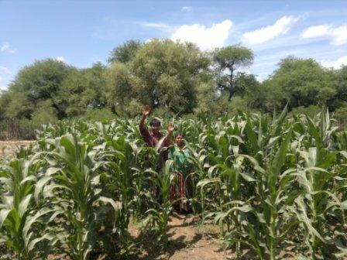
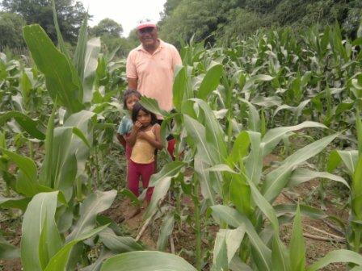
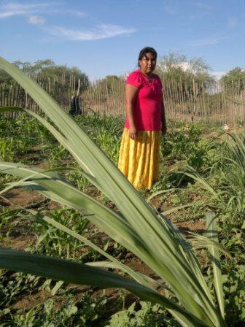
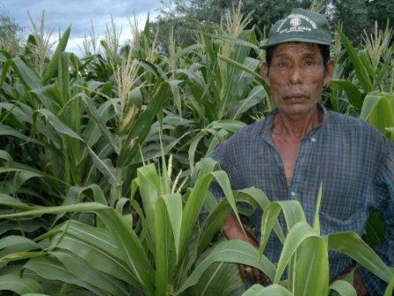
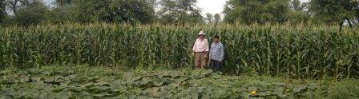
Above gardens in Santa María, Pozo Tigre and San Luis. On this trip we visited 2 communities we had never gone to (Pozo Tigre and Km 2 - Misión La Paz ). It’s difficult to spread out too much because of the time factor and you can never visit all and have personal visits as is the best way to keep the wheel turning.
Here one gardener in Pozo Tigre that irrigates with no drip hoses but in the furrow.
https://www.facebook.com/photo.php?v=430193697106389&set=vb.100003472876345&type=2&theater

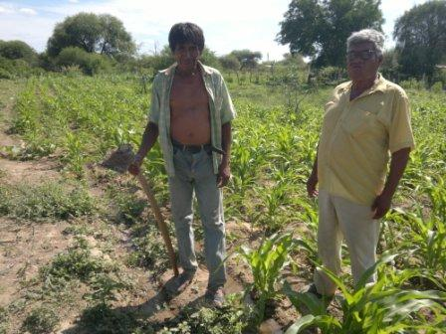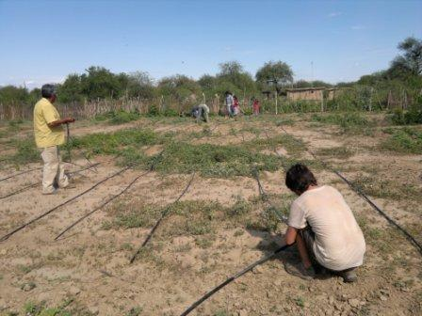

Above right is my son Pedro, who came with me this time, and Francisco helping to set up the irrigation grid for this man here with Francisco Perez, head of the entity that represents all the communities in the Pilcomayo.

To have Francisco as part of our team is strategic. He was trained originally as an agriculturist by the social program of the church so he is always interested in producing food through agriculture. Other than that, he has been a good friend for the last 34 years!
I asked him to share a few words as to the future of this “little” project. I’m concerned that this project that is working well as it is will stop if we step aside. Francisco asks that this can be part of the development process when they sometime (!!!) get their land. If you understand Spanish here his wise words:

https://www.facebook.com/photo.php?v=430010383791387&set=vb.100003472876345&type=2&theater

While we were chatting in the truck we went back to this theme of the government getting involved in agriculture. He is very negative as to their involvement as he sees they don’t have the commitment and it will fail (“salary simdrome”).We were passing by the government electric company warehouse and he says: “Look, this place has 2 employees that work on 2 shifts. None of the 2 appear…” It seems the only way is that this sort of project carries on but with good committed people. I have to mention that for a couple of months we had the support of the minister of health, Dr Heredia and we were able to buy materials for many families. All of as sudden they closed the tap and now we can’t buy materials billing them. I don’t know what is the meaning of this, if it’s due to budget (really it’s very little we are spending) or quite possible I stood on some toe… Showing what you can do with no secretary or office or truck puts many people nervous in the government because they have all the offices, secretaries, and trucks but no fruits!
Having worked initially with the Church’s social programme over 30 years ago and as a member of their same Church in Salta gives us an open door to work with the Wichí. Constantly I see that the people thank the “hermanos” (brothers) for the support. They don’t thank friends or political party but they see my work stemming from Christian roots. This is strengthened by the fact that I mention that other brothers living far away (“tojueeeeeeeeii” the longer the word the farther away it is!) are helping them. Brothers helping brothers.
I’m invited to pray for the sick which would not happen if they see me as a normal social worker. This as I said before is strategic to the acceptance of the agriculture we propose and should be also a big reason why we can do thing while Father Gobelli couldn’t…

Here are two pastors we support
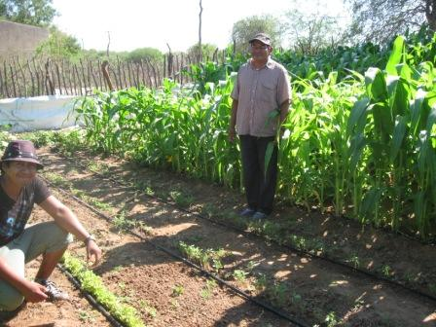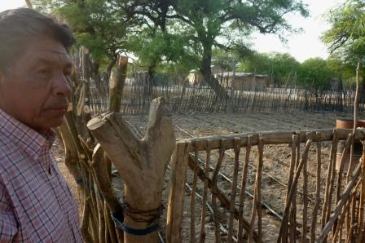
Lino Tomás from Hickman and Elias Torres from San Luis
You can hear them in the links below:
https://www.facebook.com/photo.php?v=425638824228543&set=vb.100003472876345&type=2&theater

https://www.facebook.com/photo.php?v=430104503781975&set=vb.100003472876345&type=2&theater

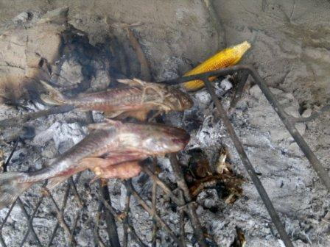

Fish and maize. When I saw these on the embers I thought this was healthy in every way. For our spiritual and material life…

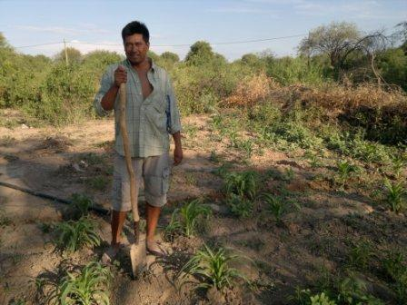
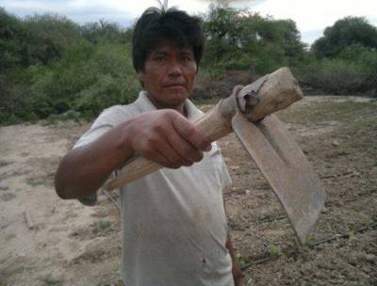

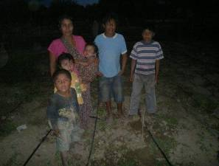
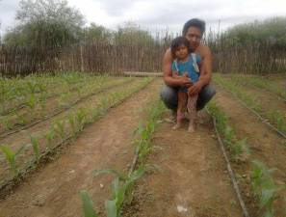
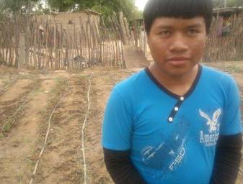
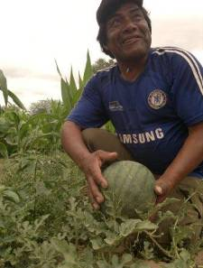
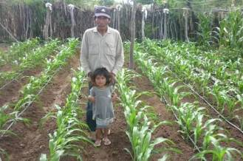
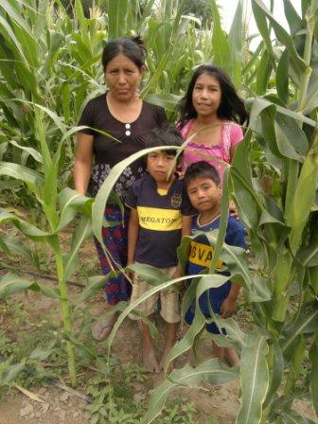
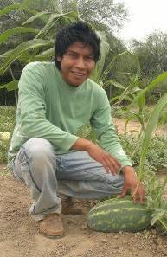
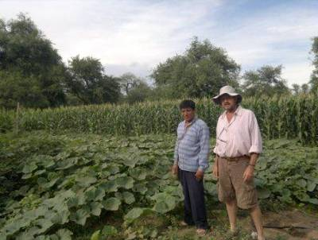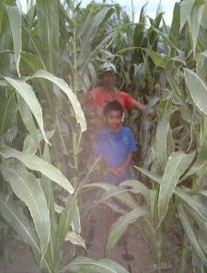

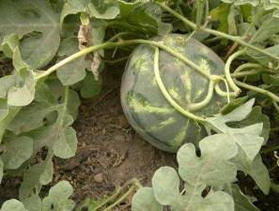
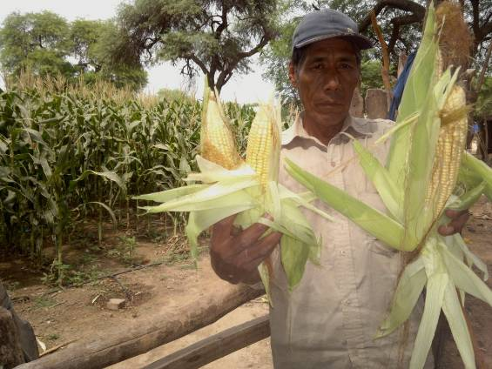
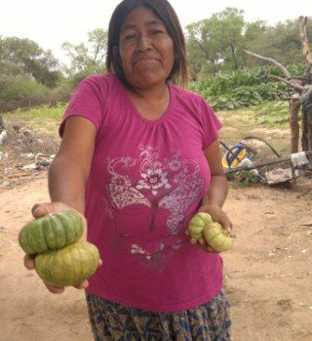

We are also doing extension work with other institutions that want to help the Wichí. One of our team goes to work with the institution and they get paid by them. In some cases they pay Siwok Foundation for the coordination also. These are the people that are asking for help:
- Manos Abiertas (Tartagal area)
- Nutrition area of the Ministry of Health (Tartagal area)
- Pluspetrol´s social responsibility program. (Potrillo area in Formosa province)

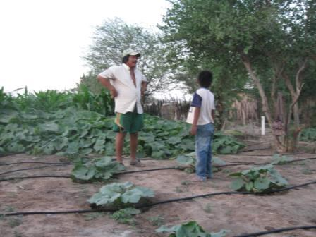
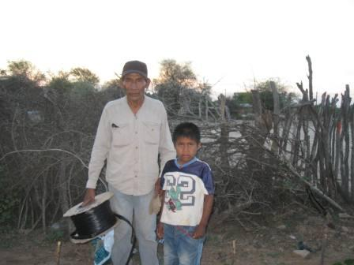

Here we see Antonio far from home in Potrillo. Interesting his family came from this area and he stays with uncles there whom he is also instructing in producing with drip irrigation.

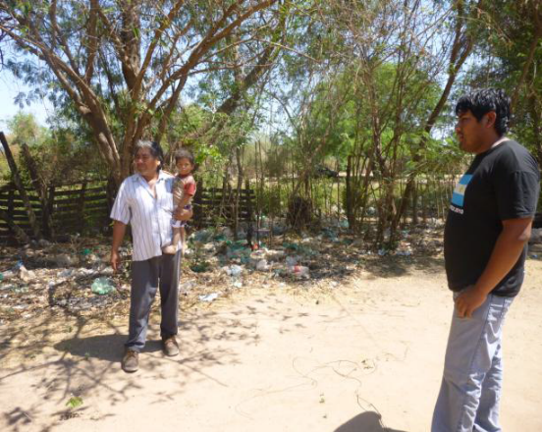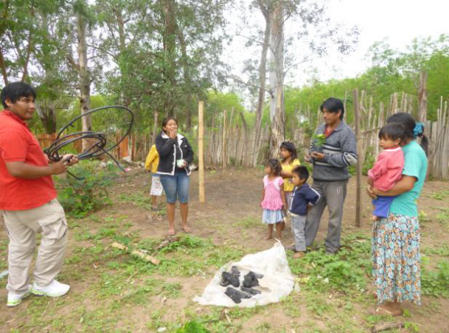

Here is Francisco Gomez, Antonio´s son doing extension work in the Tartagal area. My dream is that when the government sets up it’s agricultural program these people will be taken on because they are now trained to do the work. Similar to what happened to Wichí nurses. The medical missionaries trained the nurses and then these were taken on by the ministry of health.

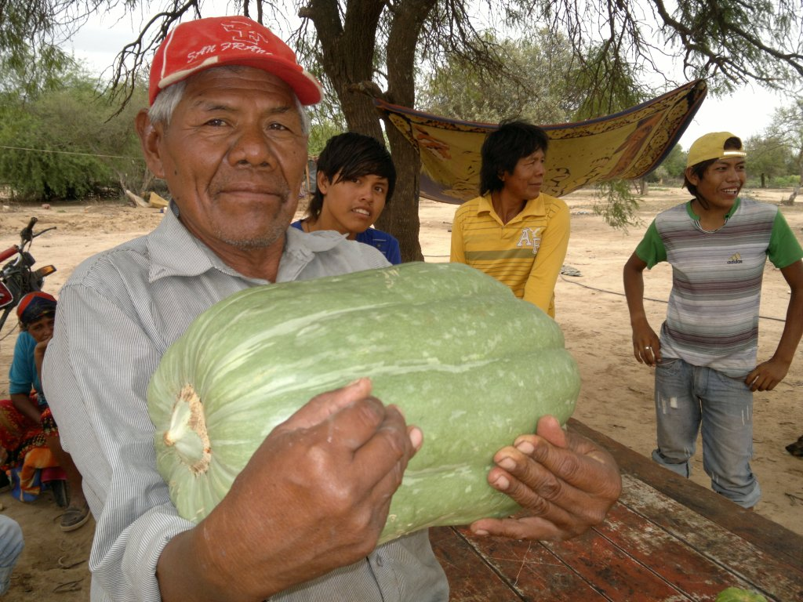

CONCLUSIONS

- It seems that to work with the Wichí in development you have to adapt to them (language, think small, belong to the church, etc) and have true commitment, not running away from the wolf... If they know you are a Christian brother, even better!
- The garden project is bearing good results. 40 gardens in the Misión Chaqueña area and between 40 and 60 in the Pilcomayo area. We are contacting new communities and as it is early in the sowing season more families will get involved as the months go on.
- We could have sold many more tomatoes this winter and the people have understood that. We plan to start working on that from February next, sowing the seed that will produce from May to September.
- When we started work three years ago there were 8 water wells that were done but didn’t produce water. Now they all are producing, that is good news.
- Our support for materials comes from a seed company and my friends and contacts but it’s not enough. There are many needs, especially in better access to water.
- Now I now understand why the minister backed off supporting our work; he is resigning in a week. I’ll have to re formulate my strategy to look for support.
- We need to generate support from other sources and being in contact with friends in the UK and US can be a solution. We’re working to get donations channeled to us through SAMS UK & Ireland.
- If anybody wants to help with a new camera it would be very welcome. It helps to show what’s happening to the other end.
- I’m using my own personal vehicle and this is 10 years old. We need to look for donors as although it takes me and brings me back it’s not sustainable on the long run. I will be pushing the government to take this responsibility.
- The Wichí and ourselves at Siwok are very thankful for the support our extended Christian family gives us. This support is strategic for this project to go forward to many more.

Alec Deane
alecdeane@yahoo.com
0054 387 5096482
BONUS: Pumpkin in Misión Chaqueña



