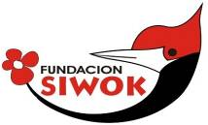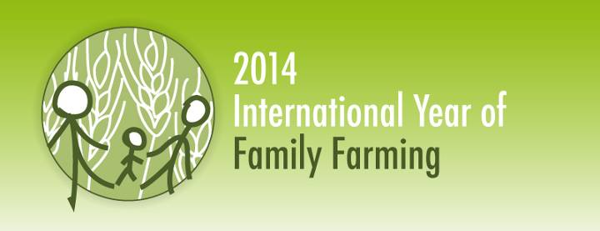

“YACHUYAJ WO” GARDEN REPORT
FEBUARY 2014
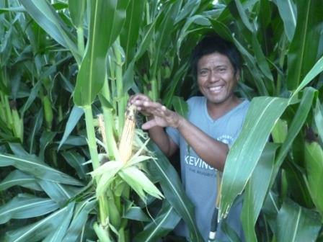
Piojito fwaj from San Luis

We were doing our rounds in San Luis community and this young man above was following. I had forgotten we had helped him with an irrigation kit a few months ago and he wanted to show us his plot. Maize was ripe and he was very proud and happy about it. You can hear him talk in wichi language:
https://www.facebook.com/photo.php?v=463829420409483&set=vb.100003472876345&type=2&theater

"very good... I like Siwok and am very happy that I´ve been given the hoses (drip irrigation) by Siwok. I´m very happy with the work Siwok gives to the Wichi which helps me so that I can eat and sell my produce. That´s all I have to say…”

These little stories crop up in the visits to the communities where with very little help we can make such a big difference to the lives of the Wichi.
The number of families that are adopting drip irrigation is growing steadily and is now over 100. This week I got notice that 4 more irrigation kits were given by Antonio in Misión Chaqueña and Francisco Perez is asking also for hoses for 4 more families in the Pilcomayo. I sent the hoses yesterday so that the wheel does not stop rolling.

Some words from Francisco who is the leader of all the communities on the Pilcomayo.
https://www.facebook.com/photo.php?v=464031563722602&set=vb.100003472876345&type=2&theater

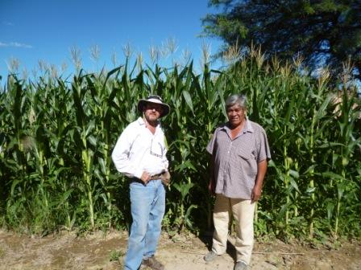
He says:
“All these years we have been looking for ways to sow but the heat comes and all is lost…
Now with the drip hoses look what we have… and this is the 2nd or 3rd harvest we are doing. Now we are all eating “choclos”!! (maize cobs). This is secure but there are places where people want to sow but there is no water… I think this is a way to work that can help our lives but we have to have water. With the heat in a day the plants dry up, water is the problem…”

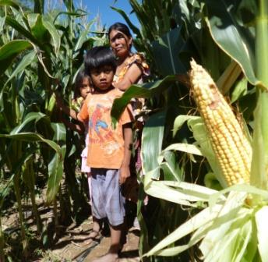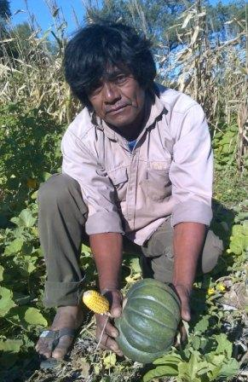

Indeed the results are promising but we need support for better water infrastructure and that can come mostly from government support.
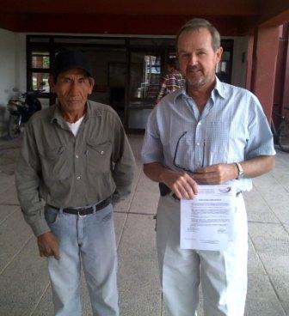
That is why we have presented 3 projects to government institutions. The biggest project went to the National Ministry of Agriculture. They have been generous in their promise to help but yet no concrete funds. I also went with Antonio Gomez, my right hand man in Misión Chaqueña, to visit the Secretary of Agriculture of the province of Salta. Here just before entering the government office with the letter of needs.
We were well received but promises were all we got as no funds have been received yet.

On my last trip to the Pilcomayo got to La Puntana Chica, generally we are very well received, but this last time Dalmacio Segundo the chief of the community hit us hard saying we just bring a little handful of seed and some hoses. He was fed up and wanted serious support. He caught us off balance as always all are happy when we arrive but I have made a note of what he was asking and we will give him solutions on our next trip. The needs are varied but hoses and a bigger tank are high on the list. Here a couple of examples on needs:

https://www.facebook.com/photo.php?v=463999360392489&set=vb.100003472876345&type=2&theater

https://www.facebook.com/photo.php?v=463990183726740&set=vb.100003472876345&type=2&theater

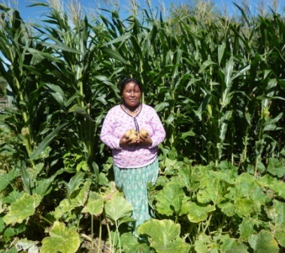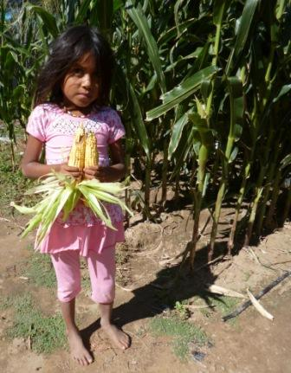

Where there is water food can be produced.
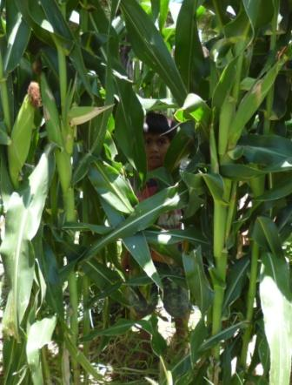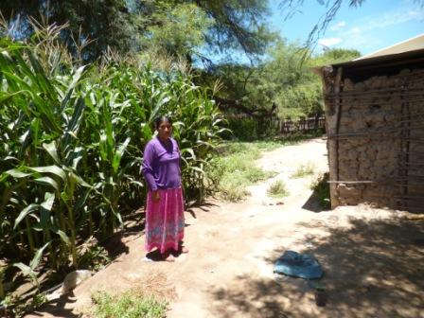

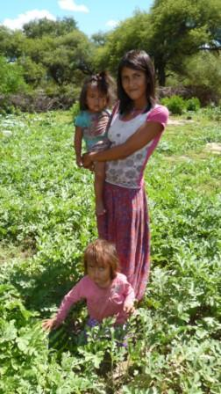
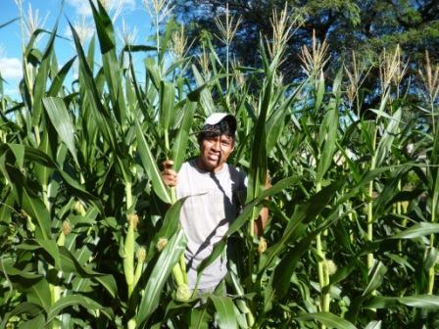

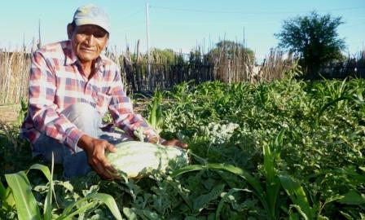

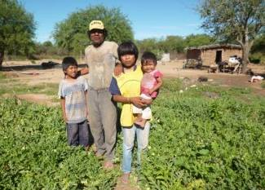
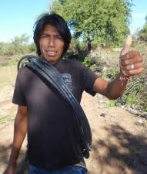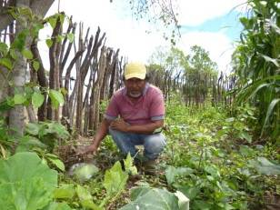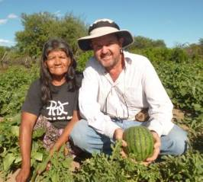
On my trip to the Pilcomayo I stay at Cris and Helena Wallis´s house. Cris is now working in Christian Education and he works with Ed Brice who goes from Tartagal (3 hours away when there is no mud…) to Santa María where Cris lives. I was asked if I could take Ed back to Tartagal and he accompanied us in that lap. He kindly wrote some impressions on what he saw and here are his words:
5:45 am isn't that early, I suppose, but at the end of January in Sta. María, a community on the Pilcomayo, it tends to be the coolest part of the night and so a good time for sleeping, add to that the fact that it was still dark and we were dependant on a simple oil lamp and torch to dress and pack by and you'll understand that Alec's morning call wasn't very welcome. However, through the haze of sleep, I reminded myself that the river was rising and if it hadn't cut the road already it was certain to do it later in the day this might be my last chance to get back to Tartagal for a while.
Being a new comer to the Anglican work in Northern Argentina I depend heavily on other people who have, over the years, developed relationships of trust and respect and have a wealth of knowledge of the different Indian Communities. What´s more very few expensive all terrain vehicles are available in the diocese but they provide much better access and permit greater flexibility than the local bus service. So those are a few very good reason why someone like Alec is such a valuable asset to the team with his excellent knowledge and regular trips to many of the communities I need to visit as part of the Christian Education team.
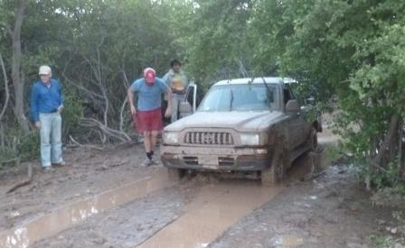
As was famously said some years ago: “they can’t eat prayer”. In addition to the very real spiritual hunger which the Christian Education team, and others, seek to address, the Indian communities also suffer from an inadequate diet. God has called us to demonstrate his love in a holistic way. As I followed Alec around in his visit to the different families in Puntana community I saw the beautiful lush stands of sweet corn, water melon and pumpkins, green peppers and traditional beans. This was testimony to what can be done with the right resources and know how. But more exciting was the enthusiasm and gratitude which this new initiative has generated. All the families involved seem to be wanting to extend the area of production as they see the potential of this kind of irrigation for themselves. Some boasted of having enough to be able to sell to visitor from over the boarder in Bolivia. I have never seen so much genuine enthusiasm for vegetable horticulture in a Chaco Indian community before.

Ed above left thinking: “why did I hitch a ride with these guys…?” See the mud at:
https://www.facebook.com/photo.php?v=464068547052237&set=vb.100003472876345&type=2&theater

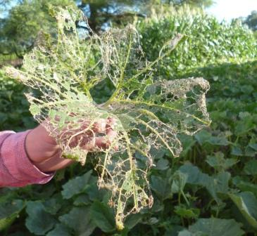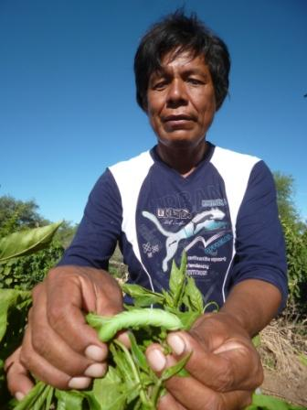
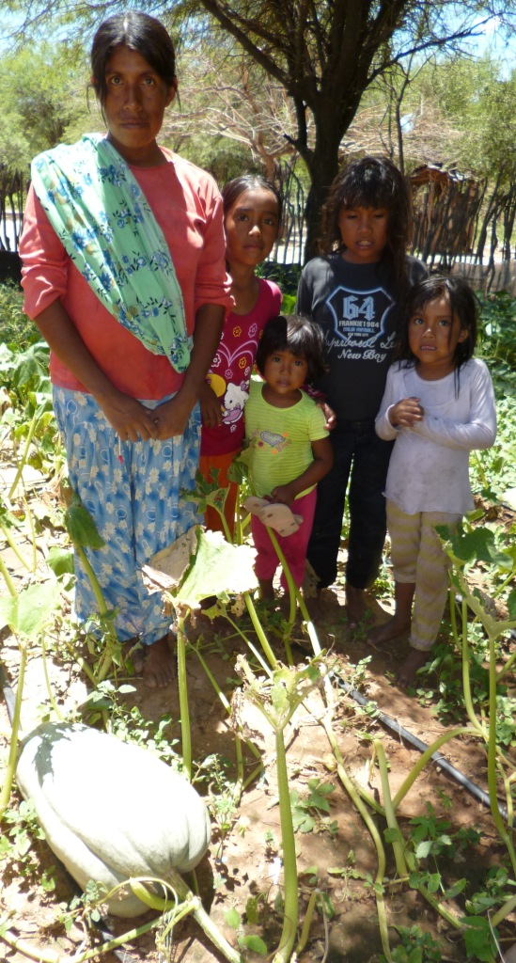
I was wise enough to take insecticide as caterpillars were eating all the pumpkin and pepper leaves.

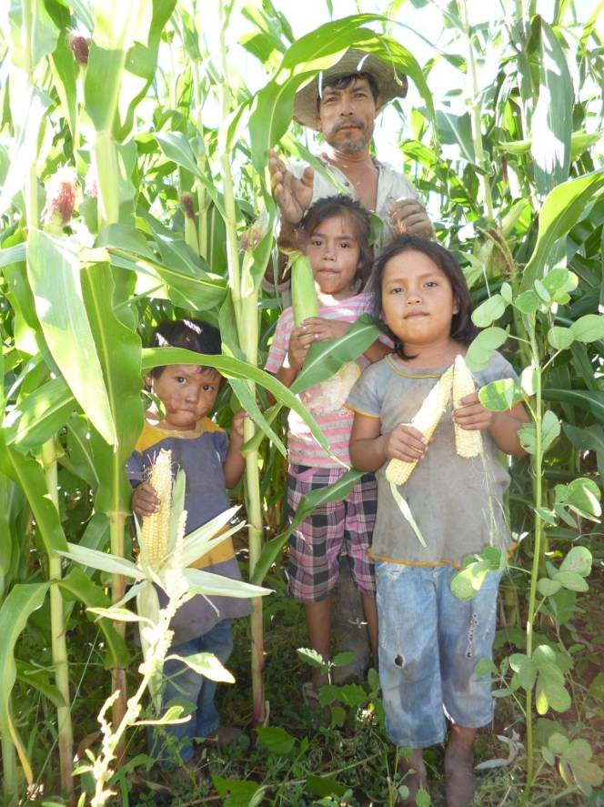
The maize seed we sow is not attacked by caterpillars so no spraying is needed. I must mention that it’s politically incorrect as it’s GE (Genetically Engineered) but I must say it has been the key to success in the many gardens we are working. Without this most maize plots would be destroyed by caterpillars. If somebody reads this that promotes family agriculture in the 3rd world I truly recommend it as no insecticide has to be used. Learn more clicking: http://www.nature.com/scitable/knowledge/library/use-and-impact-of-bt-maize-46975413

We timed our exit from the Pilcomayo quite neatly as a couple of hours after we left Santa María the river rose and cut the road and nobody was able to get out for 10 days.
You can see the normally gentle river here:

https://www.facebook.com/photo.php?v=463850567074035&set=vb.100003472876345&type=2&theater
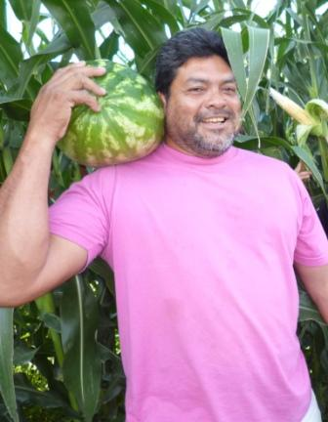
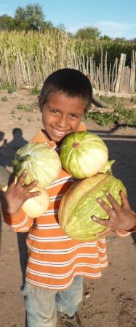
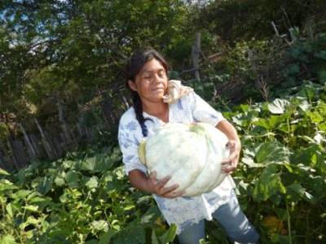
Although we talk of hunter gatherers the wichi always sowed maize, beans and pumpkin in the rainy season hidden in the forest. I believe that not wanting to change these culturally accepted species plus drip hoses has been the reason why this is successful. Here some harvest from the Misión Chaqueña area.

Avelina, photo above left has nine children. She is very thankful and says: "I thank Alec that helps us and we are very happy. The children are well and we are now harvesting. Thank you very much...”
https://www.facebook.com/photo.php?v=454412301351195&set=vb.100003472876345&type=2&theater
Blducho Villafuerte (centre) is a community leader and a enthusiastic gardener, these are a summary of his wise words:
What do you have here…? this is a watermelon for you Alec. We have maize here. This is very good Alec, thanks to the pump we were able to get through the project we had. With that tool we now have water and we are producing. There are many other families that have a garden also but we must do better for the community. We should also broaden our garden, that is the objective. There is much to do but we are working…I remember when I started cleaning my plot here you came and gave me encouragement so as to go forward. Those days we didn´t have anything… no water, not a meter of hose. Now we have our own irrigation and we are producing this is good. We are getting to our objective…

https://www.facebook.com/photo.php?v=454427138016378&notif_t=like

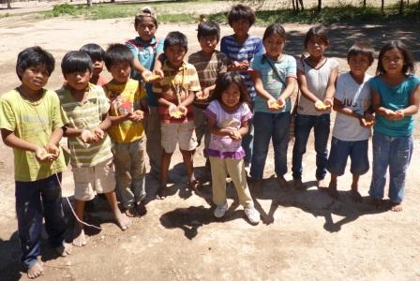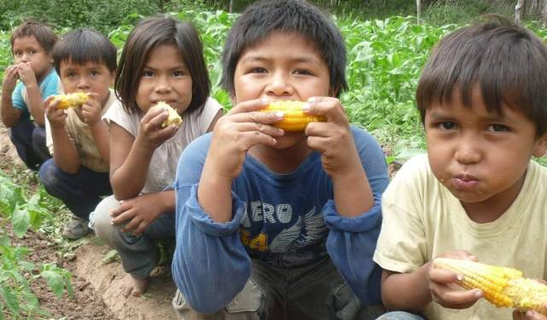

These kids at left come asking for seed and I think it´s good that they start to sow early. Agriculture based on drip irrigation will be a must in the future if they want to live with dignity in their own land.

If the the low quality formal education carries on as it is the future for these children will still be bleak. Hear Balducho, once again, asking officials that the new secondary school being built at Misión Chaqueña can offer quality education. Building schools puts the politicians in the photo for the inauguration but working on quality education that bears fruits in 10 years is not interesting to them.
https://www.facebook.com/photo.php?v=454497131342712&set=vb.100003472876345&type=2&theater
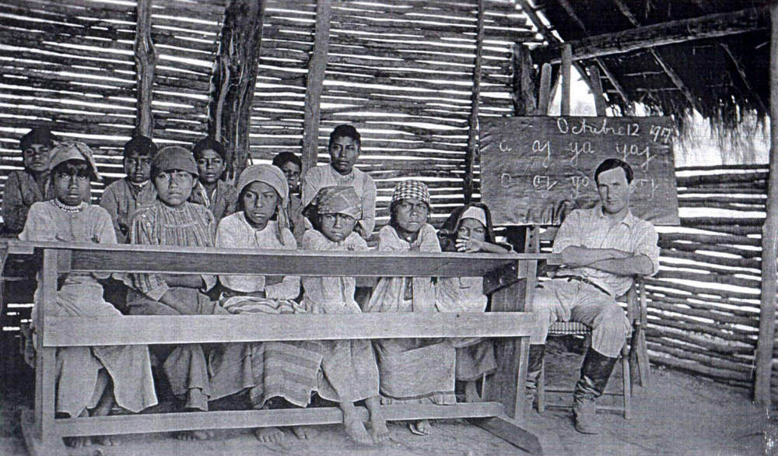
This man has understood that what secondary students receive is less than mediocre and they have no possibility to study in university. He knows this from personal experience as his son and daughter had to restudy all again when they went to Salta to study to be teachers. Not many Wichi have 2 sons with a professional degree.
Here left is a 1917 photo of a missionary at Misión Chaqueña teaching to read in their own language. We´ve come a long way but there is much to do yet.

I hope that institutions take heed of the urgent need to better education. For this we hope to be part of a push of a network of institutions pooled together by REDES CHACO They have been able to unite most institutions connected to the Gran Chaco forest of Bolivia, Paraguay and Argentina. http://www.redeschaco.org/index.php/joomlart/quienes-somos .
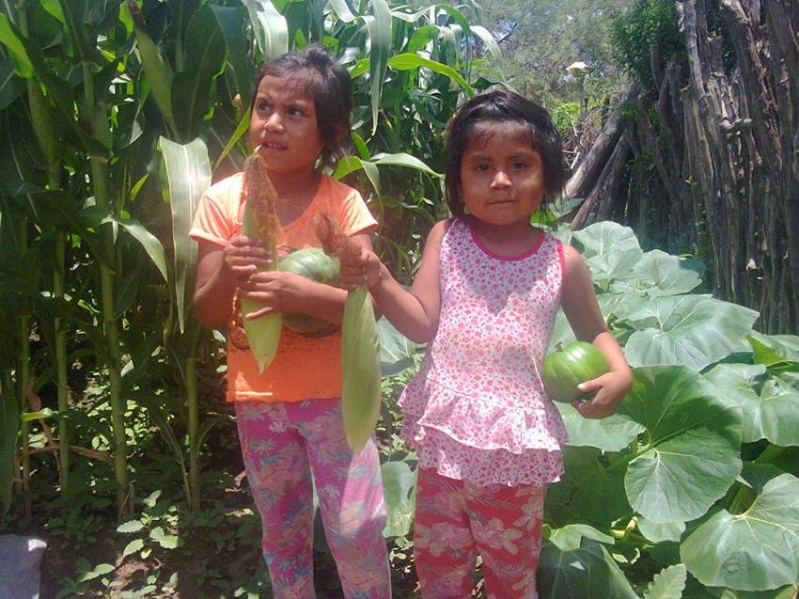
You will see reports in future of what we are trying to achieve in the education field.
If malnutrition and infant mortality are rampant there are urgent actions that have to be taken and pushing for quality education is basic (as also offering better access to water…). My first suggestion is that there has to be an exam taken by external personnel so as to evaluate how children are learning. Now all wichi get through to the next form even if the kids don’t know the curricula.


We have made contact with this ecumenical organization to finance a couple of wells in Misión Chaqueña and also so that Fundación Siwok has it´s own hand drilling equipment.


We contacted INTI with regards to tools for the wells and they proposed that we finance a course for the wichi to learn to do drill hand wells themselves and they would leave all the tools to us. This we are doing next week.



We have also presented a project to the Swiss Embassy
in Buenos Aires teamed up the NGO Manos Abiertas
to share the know how on how to do drip irrigation family agriculture in 8 schools in the Tartagal area. The teaching, as always, will be done by our trained wichi agriculturists.

Going back to agriculture in the Misión Chaqueña area we have developed new gardens plus expanding to communities further down the road.
Federico who was the first artisan that started making the very successful wooden duck(!!) over 30 years ago and now is one of the newcomers to agriculture with his son that is also an excellent craftman. He is very happy with his experience (although it doesn´t show!) but water is still the problem as in most other communities. https://www.facebook.com/photo.php?v=454417861350639&set=vb.100003472876345&type=2&theater
This he says:
“I´m F.Gomez from Misión Chaqueña. With my son this year I started to sow and we have harvested something. I liked it very much and I think we will carry on but we have a problem: water. We don´t have enough water. Me and my son want to carry on doing agriculture. Thanks to people that helped and Alec that helped us a little, we will carry on… If you help us we will sow more and we will have more to eat…”

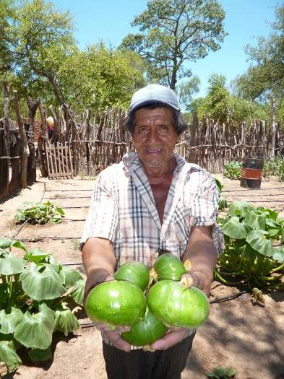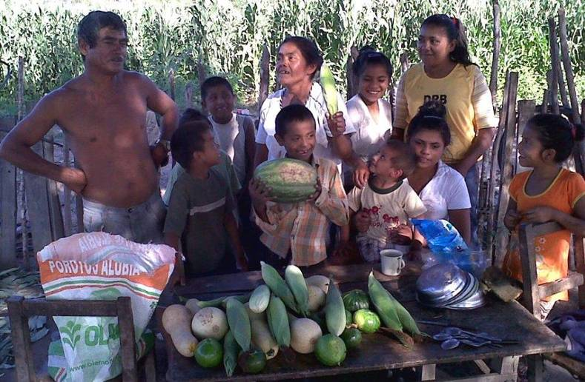

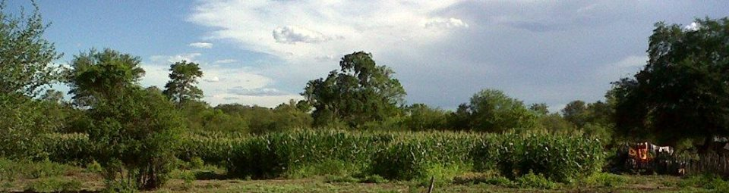

Above left gardens in San Ignacio where we now have 4 new families with gardens. To the right and below harvest in Salim and a lovely scene of irrigated maize in the hottest dry month.

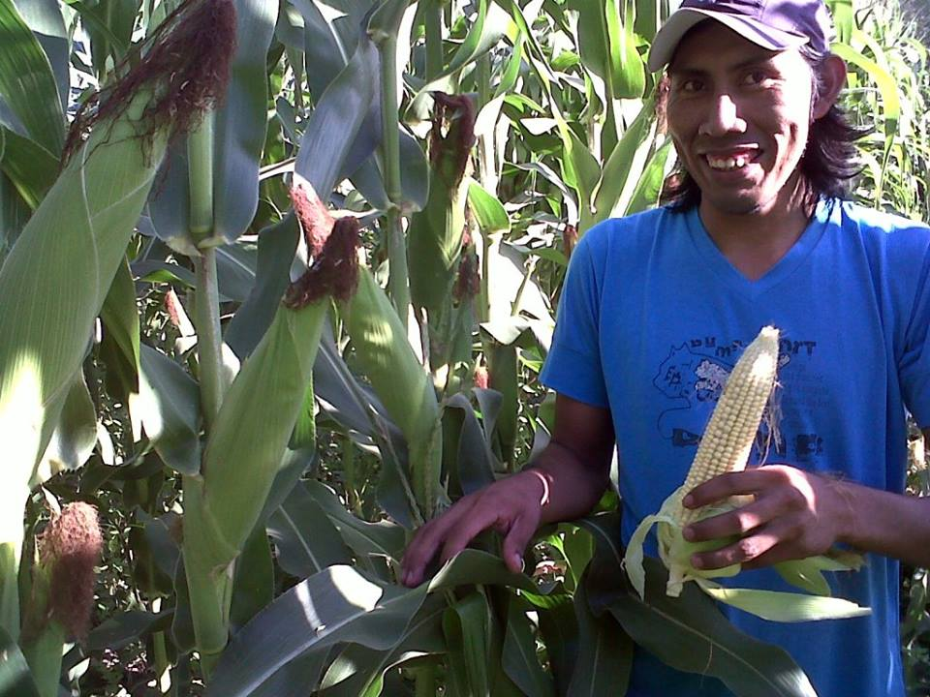
Above, good maize cobs in Alejandro Vazquez´s plot in Mision Salim.

We are now sowing tomato seed in the trays so as to have plants for planting in 25 days from now for the winter produce under plastic. Our last years experience has taught us that there is much to be gained by producing in those months. Quality fruit and price go hand in hand in autumn winter plantations. We will keep you informed as to how this evolves. The risk is high not because we can´t grow the tomatoes but because our government support, which we depend on, is uncertain.

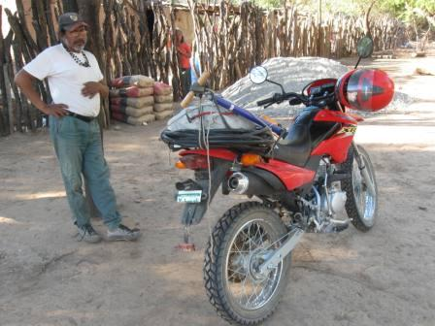
The Fundación new bike at San Ignacio community laden with hoses and air pump (basic for travelling through a forest with thorns). This valuable donation has been a very good tool to expand the work to communities far away from Misión Chaqueña. Only problem is that the upkeep has not been budgeted and we are finding it difficult to pay.

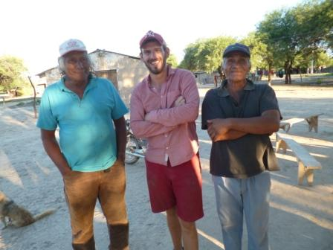
A few months ago Phil Leonard (seen happily here between 2 other Wichi Philips in San Luis community) who currently is gaining experience in the journalism world and staying in Salta offered to work “ad honorem” for the Fundación Siwok. As you know we don´t have any employees so this offer was a taken with both hands. His first task has been to put together a new web site that can open the window on what we´re doing on the short term. Although it´s not finished yet you can see part of the job by going to: www.fundacionsiwok.org We are very grateful for his enthusiasm and concrete support (plus he is good with the spade in the mud! ☺).
Some words from Phil:
I have been working with Alec and Fundación Siwok since December 2013 - this work has encompassed trips to Misión Chaqueña, Hickman, and the Pilcomayo to help with Alec’s work in these areas.

I have been very impressed by the work Fundación Siwok is doing. When you see the condition of the land, the low standard of living and the poverty of the Wichi communities, Alec’s work is even more striking and important. Through the water pumps, water transportation systems and drip-irrigation plots that ha been installed, this arid land has been transformed and now provides essential nutrition to whole families who would otherwise have to travel and buy such food. The project is also providing people with an reason to stay on their land, as oppose to moving to urban centres, a purpose to work towards, and another income stream from the sale of their crops.

On my various trips with Alec, I have talked to Wichi about the project and how it is affecting their lives. Many have told me that what Alec and Fundación Siwok is doing for them is irreplaceable and important in their communities. Previously they had to travel long distances and spend money on food, and there were constant worries and emergencies concerning their children’s health. Now, they have the food they need in their own gardens and cultivated by their own hands. Moreover, the Wichi who I have talked to have really welcomed the opportunity to work. They have told me that previously there was little work, but that now they feel they have more of a purpose and seriously enjoy what they are doing with this project.

What they need now is the support to continue these projects with new seed and new equipment. New water pumps and transportation systems would help to extend the project to those who we cannot currently reach, and new drip-hoses and piping to replace old ones which have worn out.

CONCLUSIONS

- There are more than 100 families with a garden that produce 3 and up to 4 harvests every 3 months. This is positive and should show the way for a more solid investment by larger institutions than ourselves.
- This is the International Year for Family Agriculture as you see in the logo in the first page. With this excuse we hope to bring institutions on board and generate support for expanding this food producing system based on drip irrigation and good seed to more families.
- Water is always the problem and in all the projects there will have to be investment in this area for plans to succeed.
- We are slowly being known and we hope this in the end will bring the support so that a structure of family agriculture is set up by the government with our guidelines of cultural adaptation (mainly working with Wichi agriculturalists).
- We are now sowing the winter tomato plants but with no funds. We will be depending on government support. They have promised funds but they are not yet available.
- We have taken a big risk embarking on a winter plantation but with no definite funds in the bag. It´s a “calculated risk” that hard headed Alec can take… and will kick some tables if nothing appears.
- There is much to be done in helping better the water service in the communities. All donations in this area will be much appreciated.
- We are trying to set up a system where people in other countries can support what we are doing through deposits by Pay Pal into a SAMS Ireland account. This still is not decided but we hope we can put it together shortly for the good of all.
- Just to be able to get a link to show the videos we opened a Facebook account with Fundacion Siwok. This has meant that we can get the link for the reports but also many friends can see what´s happening and hear the main actors speak. This has been an unexpected result with good fruits as we feel encouraged by the “I like” clicks!
- We will be updating our website constantly after every trip so please go to it to see what’s happening: www.fundacionsiwok.org
- Once again I mention that I´m using my own personal vehicle and this is over 10 years old. We need to look for donors as although it takes me and brings me back it´s not sustainable on the long run. Now I have to whip the horse to pass trucks!!
- Many thanks to all who show their interest and support this little initiative!! El Señor los Bendiga!

Alec Deane
alecdeane@yahoo.com

