March 2012
Dear friends,
We are coming to the end of an era, the flat is full of boxes and suitcases, and we are making those difficult decisions of what to keep or chuck or store. We will now visa allowing be leaving Brazil on 16th April (a few weeks later than we originally planned). We plan to travel South for a week at the beginning of April to see Max´s godparents in Londrina and then to spend Easter with the church in Cachoeirinha. After which we will return to Recife for a week. Please pray that we leave well, and manage to spend quality time with all our family, friends and work colleagues.
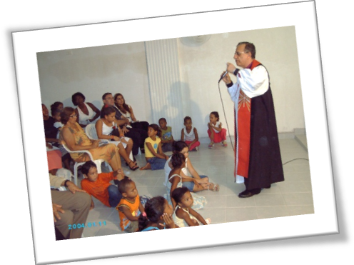We have had a terrible shock here in the Recife Diocese, our Bishop, Robinson Cavalcanti and his dear wife Miriam have been brutally murdered by their adopted son. We have fond memories of entertaining Bishop Robinson in our home, and Miriam was a great support to Efraim´s mother. It is a shock on so many levels. The funeral and burial service were attended by hundreds of folk from all strata of society, and was a testimony to how much they were loved and respected as a couple. Pastor Luis Fernando from Porto Alegre flew up for the funeral and stayed with us. Please pray for the clergy in the Diocese as they come to terms with this tragedy and choose a new Bishop.
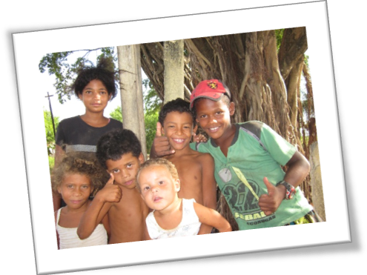Ruth is still giving health talks and supporting the pregnant women´s ministry and work with mums and babies at the House of Hope. There is a larger than usual group of pregnant women at the moment which is exciting. Please pray for more health professionals to get involved, and for Marilene (overseeing the spiritual side of things) and Rosana (overseeing the practical side).

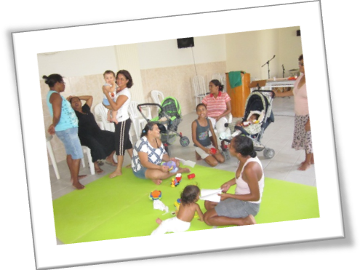Sadly the House of Hope is losing Paula who had taken on Fabi´s coordinating role. The day to day running of the crèche is being undertaken by Viviane who was previously one of the child care staff. She is doing a fantastic job, but please pray for her with this greatly increased amount of responsibility. Pray also for a new overall coordinator who can take on fundraising responsibilities etc. and a bigger team of volunteers to help with time-consuming things like collecting donations from all over Recife.
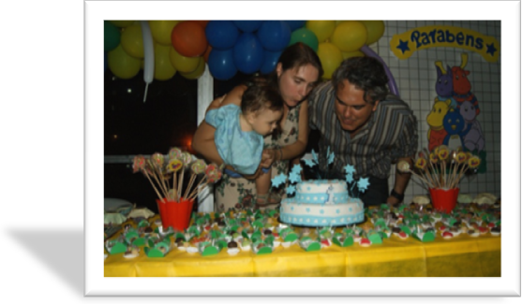Max is growing up so fast; he now enjoys kicking a football around and generally busying around non-stop. We had a very fun Brazilian 1st Birthday party for him in January which was a great opportunity for us to get family and friends together before we leave. Please pray for him over the next few months, that we manage to maintain some sort of routine for him and that he adapts well to all the changes.

Efraim is now working his last few weeks at Walmart. We were delighted with his IELTS English test result; he gained more than he needs for his studies at All Nations College and for his UK visa, thank you for your prayers. We are now praying and waiting for his visa application to be accepted.
We hope to see many of you over the next few months as we travel around. Please do get in touch as we would love to have the chance to catch up with you.

Our studies at All Nations College start in September. Also Ruth will be studying one day a month in London on an IBLCE Lactation Consultant training course. Please be praying for the right job placement after our training, we are very conscious that the year will pass by quickly!
Thank you for your prayers and support. We look forward to seeing many of you soon.
Love
Efraim, Ruth and Max
Church Mission Society, Watlington Road, Oxford OX4 6BZ
Switchboard: +44 (0)1865 787400 +44 (0)1865 787400 www.cms-uk.org

Our UK contact address:

Efraim and Ruth Vilella
c/o ‘Grouville’
74 Borstal Road
Rochester, Kent
ME1 3BD

